Using Multi-Edit

**Labels: Aruba Central**

**Requirement:**

How to use multi-edit.

**Solution:**

Use multi-edit to make additional changes for a particular device.

Go to edit config view.

[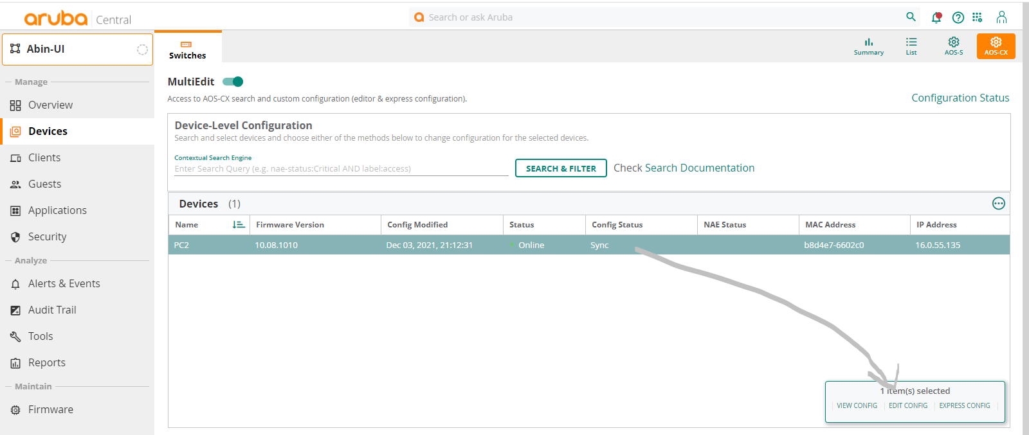](https://akb.arubanetworks.com/media/ckuploads/1110/2021/12/23/click-on-edit-config.PNG)

**Configuration:**

2. Make the changes at the last line to keep it easy.

Cons: Just like in ClI we should know what would be the next keyword.

Pros: Possible options would be shown when typed.

Do Use tabs after hitting a feature command(for example mirror session X) to add the additional configs.

After hitting enter, command would go to place in running-config where it is designed to go.

[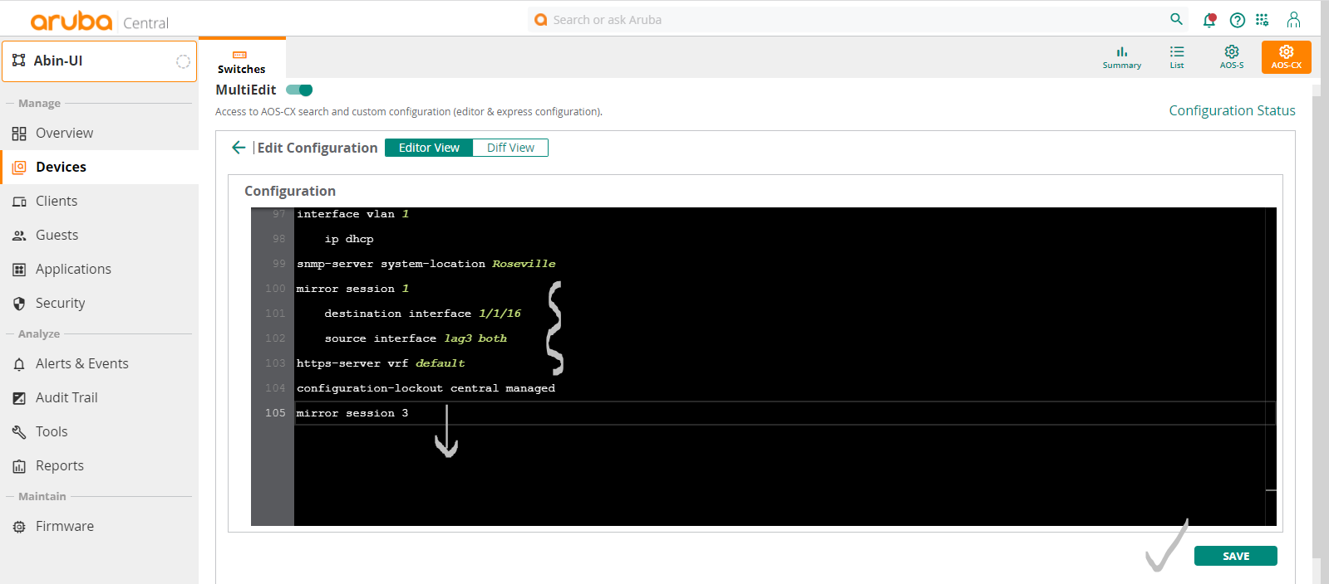](https://akb.arubanetworks.com/media/ckuploads/1110/2021/12/23/editing-the-config-and-saving.PNG)

Save it!!

**Verification:**

Might show un-sync for some time, but it should be back to sync within short time.

[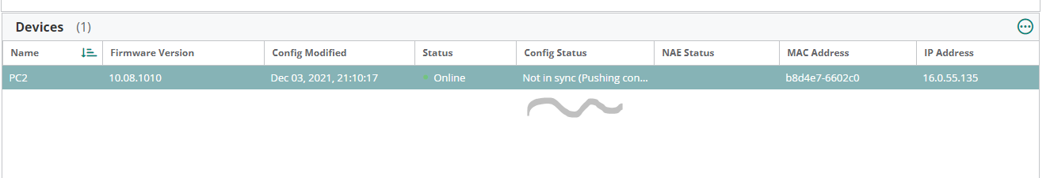](https://akb.arubanetworks.com/media/ckuploads/1110/2021/12/23/might-show-no-sync-for-sometime_FqWFqZR.PNG)

If any issue happens check back here.  
Under edit config page

[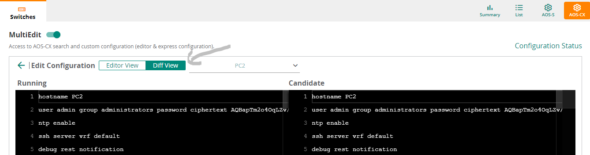](https://akb.arubanetworks.com/media/ckuploads/1110/2021/12/23/configuration-difference-check.PNG)

Tags: Aruba Central, 10.01.0040, multi-edit